**Concept quiz questions 2021.11.11**

**Note: Green** highlight means the answer that I put in and I think it’s correct, **Red** highlight means highlight means the answer that I put in but I am uncertain / think it’s wrong

**Disclaimer:** I don’t have the final answer for each question, so apply your judgment when you read them.

**Question 1:** Functions of timer interrupt

**Answer 1:** All of the above

**Option 1:**

* Forgot
* Forgot
* For the CPU to track the time of a process
* **All of the above**

**Question 2:** After execute join() WILL change state to “waiting”, True or False?

**Answer 2:** False, only change to waiting only if child threads have not finished

**Option 2:**

* True
* False, change to ready if child threads have not finished
* **False, only change to waiting only if child threads have not finished**
* False, will continue running state until child threads finish

**Question 3:** What is true for multicore partitioned CPU scheduling?

**Answer 3:** I chose option 4, I think I was wrong on this one, should be option 3

**Option 3:**

* Each threads of a process only run on the same CPU core
* Dynamic allocation of each process to each CPU core
* At each CPU burst length, static allocation of each process to one single CPU core
* **At the start instance of each process, static allocation of each process to one single CPU core (and don’t change core throughout the process)**

**Question 4:** Assume all processes have the same CPU burst length and without any I/O, however the processes may come in different time instance, which of the followings is true?

**Answer 4:** I think wrong again? I put “All different average waiting time”, should be “Same average waiting time for FIFO, SJF, different for SRTF”

**Option 4:**

* Same average waiting time for FIFO, SJF, SRTF
* Same average waiting time for SJF, SRTF, different for FIFO
* Same average waiting time for FIFO, SJF, different for SRTF
* **All different average waiting time**

**Question 5:** Which algorithm suffers from Belady anomaly?

**Answer 5:** FIFO

**Option 5:**

* **FIFO**
* Optimal
* LRU

**Question 6:** Which of the following is true for hold and wait and circular wait?

**Answer 6:** Should be correct one, “circular wait: each process in a cycle requests for a resource held by the next process in the cycle; hold and wait: processes are holding resources while requesting for others”

**Option 6:**

Similar to this:

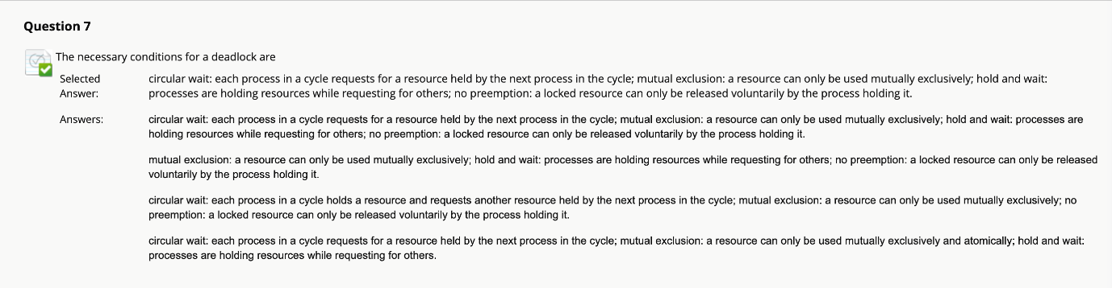

**Question 7:** Real time OS, what is the difference between DM and EDF?

**Answer 7:** DM priority based on relative deadlines, EDF priority based on absolute deadline of that time instance

**Option 7:**

* No difference
* Both based on absolute deadlines of that instance
* **DM priority based on relative deadlines, EDF priority based on absolute deadline of that time instance**
* DM based on frequency of period (T), EDF based on absolute deadline of that time instance

**Question 8:** Which of the followings is true:

**Answer 8:** Page fault means TLB miss

**Option 8:**

* TLB miss WILL lead to page fault
* Forgot
* **Page fault means TLB miss**

**Question 9:** Producer consumer mutex, assume **full** is 0 initially

Producer process:

Wait(empty);

Wait(mutex);

// add nextProduced to buffer;

Signal(full);

Signal(mutex);

Consumer process:

Wait(full);

Wait(mutex);

// nextConsumed = item from buffer;

Signal(empty);

Signal(mutex);

**Blue:** they are swapped, different from lecture slides!! (**blue** colour and its annotation is self-made by me, not shown in the question presented, but one can easily spot that their positions have been swapped)

**Answer 9:** All 1, 2, 3 are incorrect; also note: full is 0 initially, means that the buffer is totally empty initially

**Option 9:**

* Deadlock because consumer is consuming resources not available
* Consumer will consume even if the buffer is empty
* Producer will produce even if buffer is full
* **All 1, 2, 3 are incorrect**
* Only 2, 3 are incorrect

**Question 10:** In the Reader-Writer implementation, what does it mean by writers are given preference over readers?

**Answer 10:** I put in “If writer and reader in a queue waiting, writer will be given priority to get in the process over reader”, which is wrong, should be “more than one writers can be in the same process at the same time”

**Option 10:**

* Suppose readers in process, writer can get in the process concurrently
* Reader requires exclusive access
* **If writer and reader in a queue waiting, writer will be given priority to get in the process over reader**
* More than one writers can be in the same process at the same time

Note: Similar to the below, but reader and writer swap roles

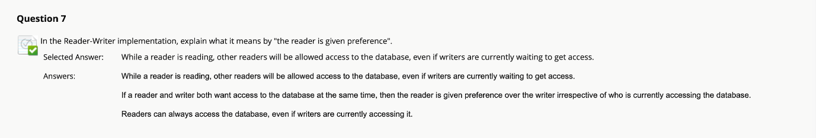

**Question 11:** Which allocation method will have internal fragmentation?

**Answer 11:** All of the above; reason: all of the allocation methods involve the use of fixed size blocks

**Option 11:**

* Contiguous allocation
* Linked allocation
* Indexed allocation
* **All of the above**

**Question 12:** Which page table will have higher overhead?

**Answer 12:** Inverted page table

**Option 12:**

* Conventional page table
* **Inverted page table**

**Question 13:** Seek time 10ms, rotational time 6ms, track has 1024 sectors, time to random access 128 sectors?

**Answer 13:** 1664.75ms, calculations: (10 + 6/2 + (1/1024)*6) * 128

**Option 13:**

* 13XX ms
* **1664.75 ms**
* 13.75 ms
* 16.XX ms

**Question 13 other variants from friends:** Seek time 10ms, rotational time 6ms, track has 1024 sectors, time to sequential access 128 sectors?

**Answer 13:** 13.75ms, calculations: 10 + 6/2 + (128/1024)*6

**Option 13:**

* 13XX ms
* 1664.75 ms
* **13.75 ms**
* 16.XX ms

**Option 14:** Symbolic link and hard link, which one true?

**Answer 14:** Using either symbolic or hard links, a file can be accessed using two absolute path names

Option 14:

* Forgot
* Forgot
* Accessing a file using hard link takes longer time than using symbolic link
* **Using either symbolic or hard links, a file can have different names**

Very similar to this, although this time the question is asking which one is true:

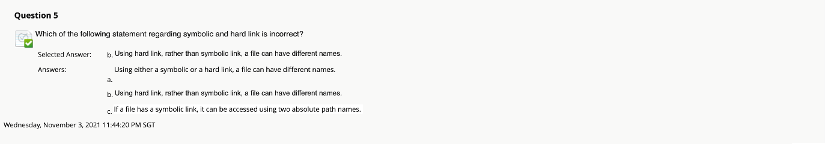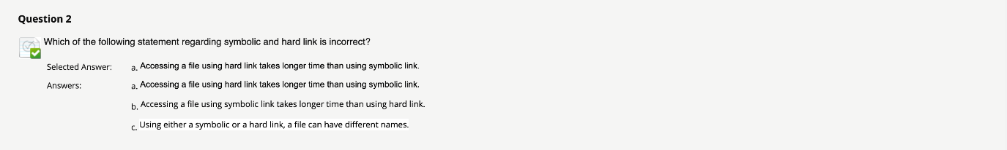

**Question 15:** Page size 1024 bytes, logical page 2^20 bytes, what is the number of entries in the page table?

**Answer 15:** 1024 送分 free score given

**Option 15:**

* 1000
* **1024**
* 2048
* 2000

**Other question from friends 1:** Which of the following set of events will not be executed by short time scheduler?

**Answer:** I don’t know

**Option:**

* Interrupt; admission of new process; I/O event
* interrupts
* Interrupt; admission of new process
* admission of new process, I/O event

**Other question from friends 2:** Which of the following set of events will not be executed by non-preemptive scheduler?

**Answer:** I don’t know

**Option:**

* Interrupt; admission of new process; I/O event
* interrupts
* Interrupt; admission of new process
* admission of new process, I/O event